**SQL QUERIES**

1. **What are top 10 most popular educational courses on Coursera based on the number of students enrolled?**

SELECT TOP 10

course_title,

course_organization,

course_certificate_type,

course_students_enrolled,

course_duration

FROM coursera_courses

ORDER BY course_students_enrolled DESC;

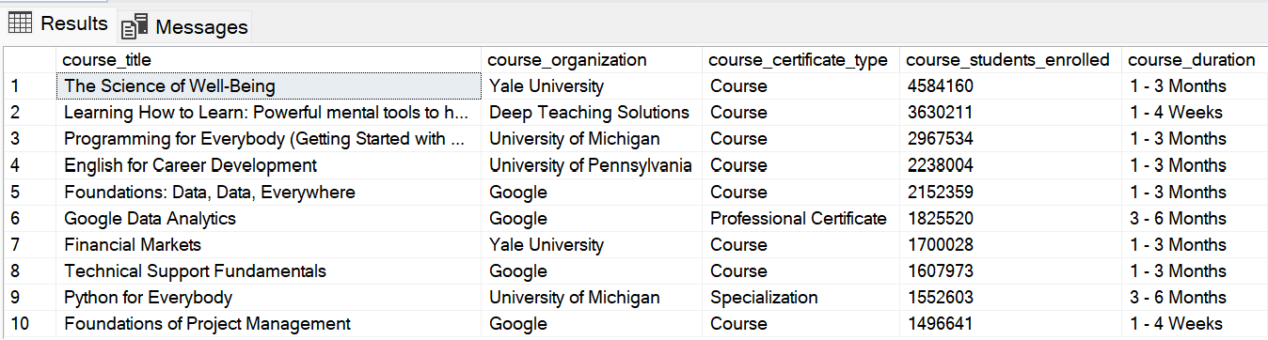

1. **Are there any trends or patterns in the duration of courses? Do shorter or longer courses tend to be more popular?**

**Part 1: By number of courses**

SELECT

course_duration,

COUNT(course_duration) AS Total_in_Number,

(COUNT(course_duration)*100.0/(SELECT COUNT(course_duration) FROM coursera_courses)) AS In_Percentage

FROM coursera_courses

GROUP BY course_duration

ORDER BY Total_in_Number DESC;

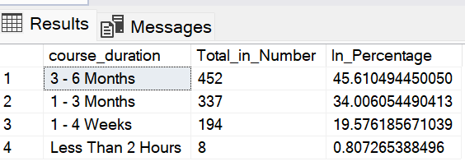

**Part 2: By number of students enrolled**

SELECT TOP 20

course_title,

course_organization,

course_certificate_type,

course_duration,

course_students_enrolled

FROM coursera_courses

ORDER BY course_students_enrolled DESC;

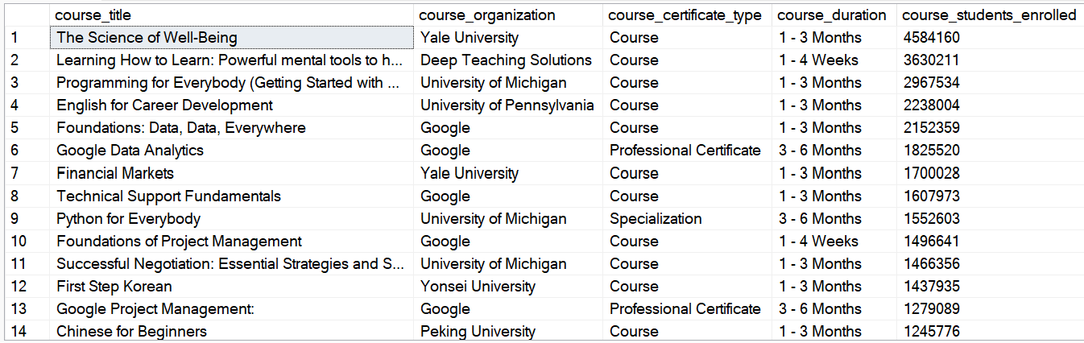

*Observation: Longer courses are more popular than shorter courses. 45.6% of all courses have 3 – 6 months duration and 34.0% have 1 – 3 months duration. Only 8.0% of the courses have less than 2 hours duration. Additionally, 16 out of the top 20 popular courses (based on the number of students enrolled) have a duration of at least 1 – 3 months. Those with one month or less are only 4.*

1. **Which certificate types are most in-demand?**

**Part 1: By number of courses**

SELECT

course_certificate_type,

COUNT(course_certificate_type) AS Number_of_Courses,

(COUNT(course_certificate_type)*100.0/(SELECT COUNT(course_certificate_type) FROM coursera_courses)) AS In_Percentage

FROM coursera_courses

GROUP BY course_certificate_type

ORDER BY Number_of_Courses DESC;

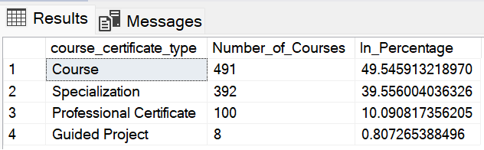

**Part 2: By number of students enrolled**

SELECT TOP 20

course_title,

course_organization,

course_students_enrolled,

course_certificate_type

FROM coursera_courses

ORDER BY course_students_enrolled DESC;

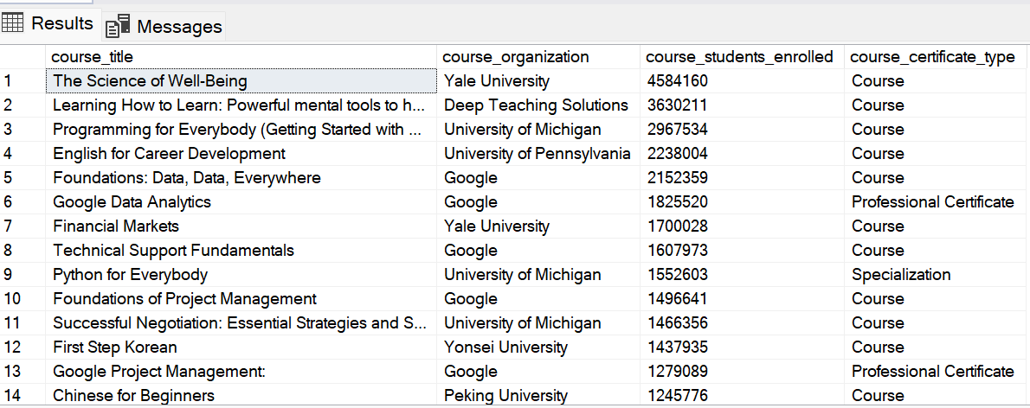

*Observation: Courses are the most in-demand compare to other certificate types. 49.5% of all the certificates are Courses, 39.6% are Specializations, and 10.1% are Professional certificates. Also, 17 out of the top 20 most popular courses (based on the number of students enrolled) are Courses; 2 are Professional certificates, and one is a specialization.*

1. **Are there specific organizations that stand out for offering high-quality courses or attracting a large number of students?**

SELECT

course_organization,

COUNT(course_organization) AS Number_of_Courses,

(COUNT(course_organization)*100.0/(SELECT COUNT(course_organization) FROM coursera_courses)) AS Percentage_of_all_Courses,

SUM(course_students_enrolled) AS Number_of_Students,

(SUM(course_students_enrolled)*100.0/(SELECT SUM(course_students_enrolled) FROM coursera_courses)) AS Percentage_of_all_Students

FROM coursera_courses

GROUP BY course_organization

ORDER BY Number_of_Students DESC;

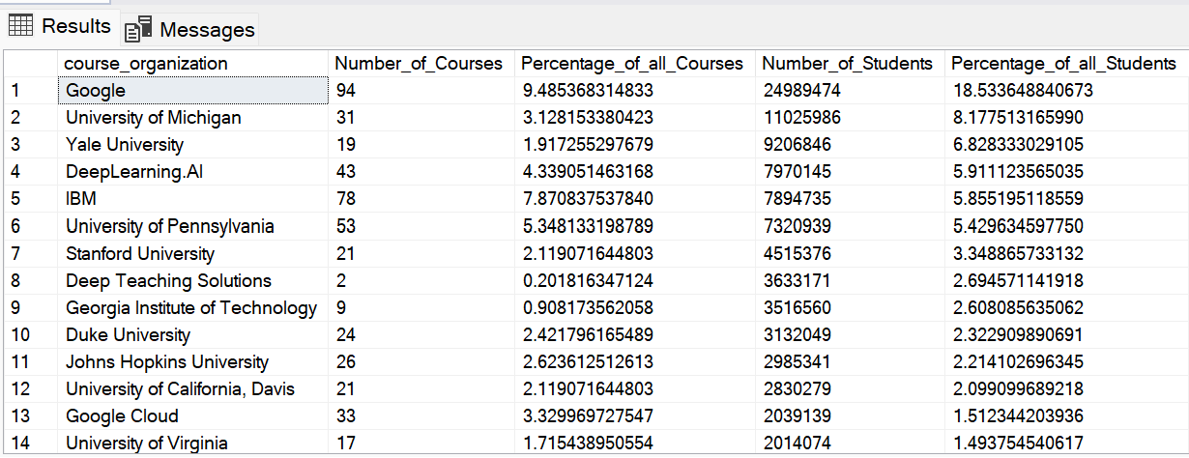

*Observation: Google is a stand out organization in terms of both the number of students enrolled and the number of courses offered. Google attracts 18.5% of all students enrolled and offers 9.5% of all courses. IBM, University of Pennsylvania, University of Michigan, and Deep Learning.AI are also in the top 5 in terms of students enrolled and number of courses offered.*

1. **What is the distribution of course levels (e.g., beginner, intermediate, advanced)? Are certain levels more prevalent than others?**

SELECT

course_level,

COUNT(course_level) AS Number_of_Courses,

(COUNT(course_level)*100.0/ (SELECT COUNT(course_level) FROM coursera_courses)) AS Percentage_of_all_Courses

FROM coursera_courses

GROUP BY course_level

ORDER BY Number_of_Courses DESC;

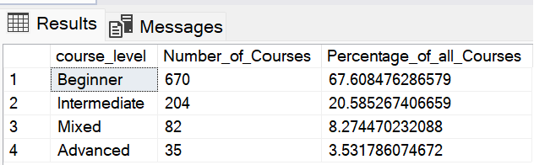

*Observation: 67.6% of all courses offered on Coursera are beginner level, 20.6% are intermediate level, 8.3% are mixed, and only 3.5% are advanced level.*

1. **Are there courses with exceptionally high or low ratings, enrollment, or other attributes?**

**Part 1: Course rating (High)**

SELECT TOP 100

course_title,

course_organization,

course_rating

FROM coursera_courses

ORDER BY course_rating DESC;

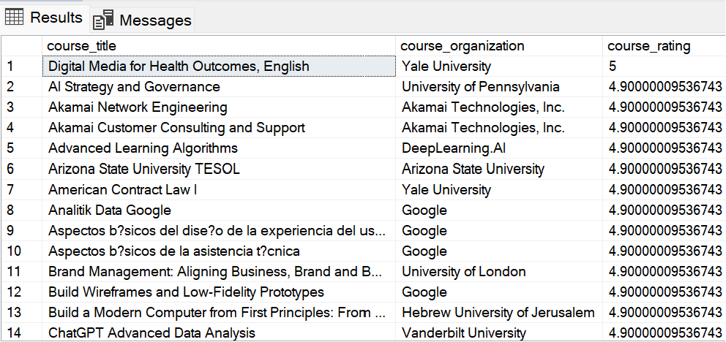

**Part 2: Course rating (Low)**

SELECT TOP 100

course_title,

course_organization,

course_rating

FROM coursera_courses

ORDER BY course_rating;

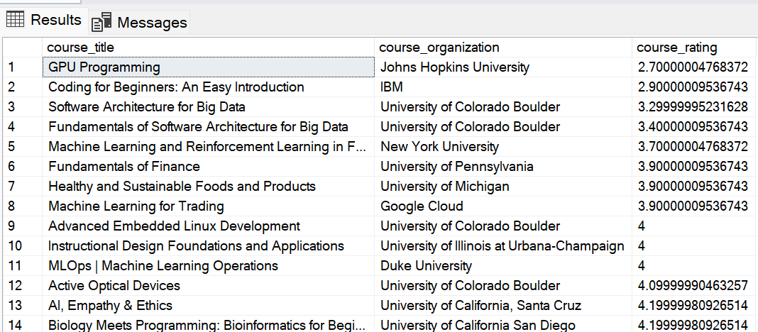

**Part 3: Student enrolment (High)**

SELECT TOP 10

course_title,

course_organization,

course_students_enrolled

FROM coursera_courses

ORDER BY course_students_enrolled DESC;

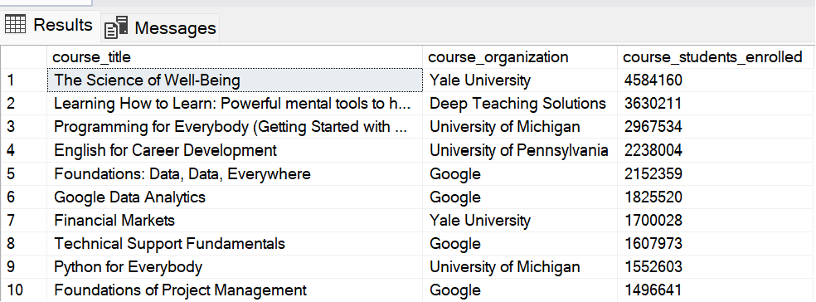

*Observation: No courses have exceptionally high rating. About 90 courses have a rating of 4.9 and above. However, 2 courses, ‘GPU Programming’ from Johns Hopkins University and ‘Coding for Beginners: An Easy Introduction’ from IBM have exceptionally low rating of 2.7 and 2.9 respectively. In terms of student enrolment, ‘The Science of Well-Being’ from Yale University and ‘Learning how to Learn: Powerful mental tools to help you master tough subjects’ have exceptionally high number of students enrolled with over 4.5 million and 3.6 million students enrolled respectively.*

1. **How do course characteristics (duration, certificate type, and level) affect the number of students enrolled or the course rating?**

**Part 1: Course duration**

SELECT

course_duration,

SUM(course_students_enrolled) AS Number_of_Students,

(SUM(course_students_enrolled)*100.0/ (SELECT SUM(course_students_enrolled) FROM coursera_courses)) AS Percentage_of_All_Students

FROM coursera_courses

GROUP BY course_duration

ORDER BY Percentage_of_All_Students DESC;

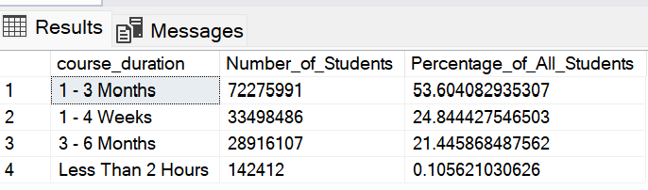

**Part 2: Certificate types**

SELECT

course_certificate_type,

SUM(course_students_enrolled) AS Number_of_Students,

(SUM(course_students_enrolled)*100.0/ (SELECT SUM(course_students_enrolled) FROM coursera_courses)) AS Percentage_of_All_Students

FROM coursera_courses

GROUP BY course_certificate_type

ORDER BY Percentage_of_All_Students DESC;

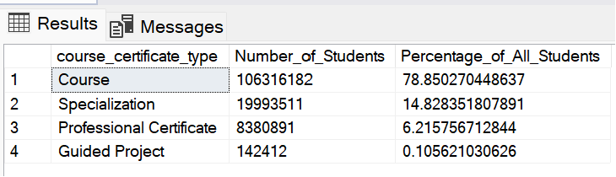

**Part 3: Course levels**

SELECT

course_level,

SUM(course_students_enrolled) AS Number_of_Students,

(SUM(course_students_enrolled)*100.0/ (SELECT SUM(course_students_enrolled) FROM coursera_courses)) AS Percentage_of_All_Students

FROM coursera_courses

GROUP BY course_level

ORDER BY Percentage_of_All_Students DESC;

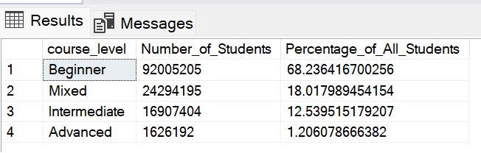

*Observation: Courses with longer duration attract the highest number of students, with those taking 1 – 3 months (53.6%) and 3 – 6 months (21.4%) attracting a whopping combined 75% of all students. Courses with the least duration of time (Less than 2 hours) attract a meagre 0.11% of all students.*

*In terms of certificate types, Courses attract the highest number of students at 78.9% of all students, while Specializations and Professional Certificates attract 14.8% and 6.2% of all students respectively. Guided Projects attract the least number of students, with only 0.11% of all students.*

*In terms of course levels, Beginner courses attract the highest number of students at 68.2%, with mixed and intermediate courses attracting 18.0% and 12.5% of all students respectively. Only 1.2% of all students enroll for advanced level courses on Coursera.*

1. **Are there any courses that are underperforming in terms of student enrollment or rating, and can you identify potential areas for improvement?**

**Part 1: Number of students enrolled**

SELECT

course_title,

course_organization,

course_students_enrolled

FROM coursera_courses

ORDER BY course_students_enrolled;

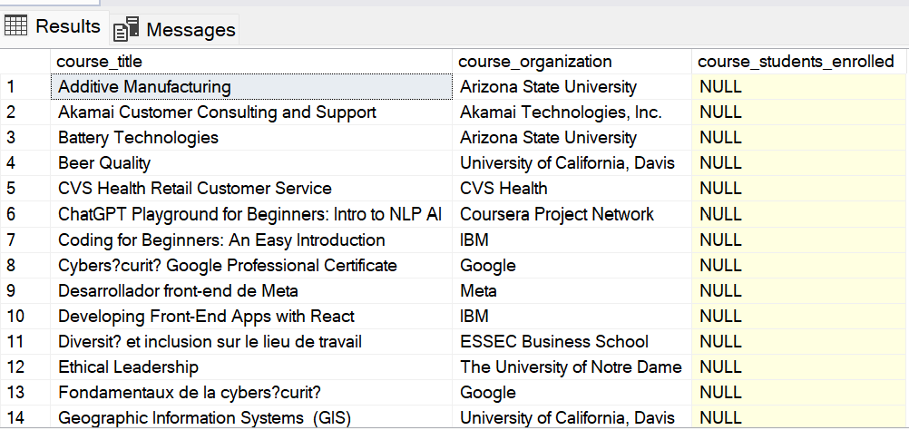

*\*This result is affected by existence of NULL values in the students enrolled column*

**Part 1: Course rating**

SELECT

course_title,

course_organization,

course_rating

FROM coursera_courses

ORDER BY course_rating;

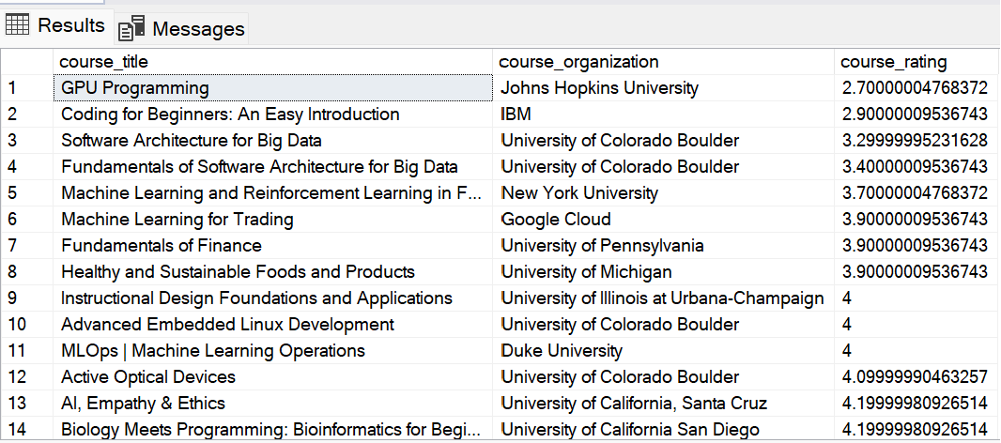

*Observation: In terms of rating, ‘GPU Programming’ from Johns Hopkins University and ‘Coding for Beginners: An Easy Introduction’ from IBM are underperforming with ratings of 2.7 and 2.9 respectively. Also, 6 other courses have a rating of less than 4.0.*

*In terms of the number of students enrolled, the results are not conclusive because of the existence of NULL values in the students enrolled column in 31 rows.*

1. **What are the top 10 performing courses in each level (beginner, intermediate, advanced, and mixed)?**

**Part 1: Top 10 Beginner level courses based on student enrollment**

SELECT TOP 10

course_title,

course_organization,

course_level,

course_students_enrolled

FROM coursera_courses

WHERE course_level = 'Beginner'

ORDER BY course_students_enrolled DESC;

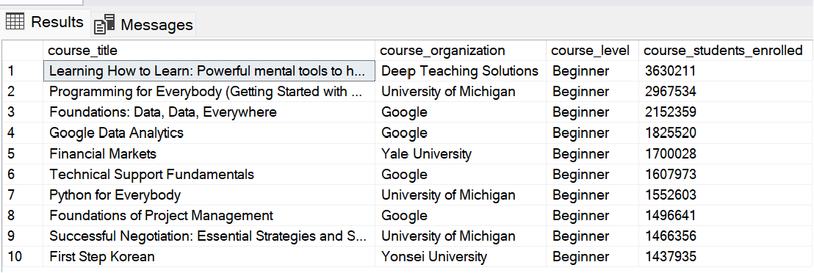

**Part 2: Top 10 Intermediate level courses based on student enrollment**

SELECT TOP 10

course_title,

course_organization,

course_level,

course_students_enrolled

FROM coursera_courses

WHERE course_level = 'Intermediate'

ORDER BY course_students_enrolled DESC;

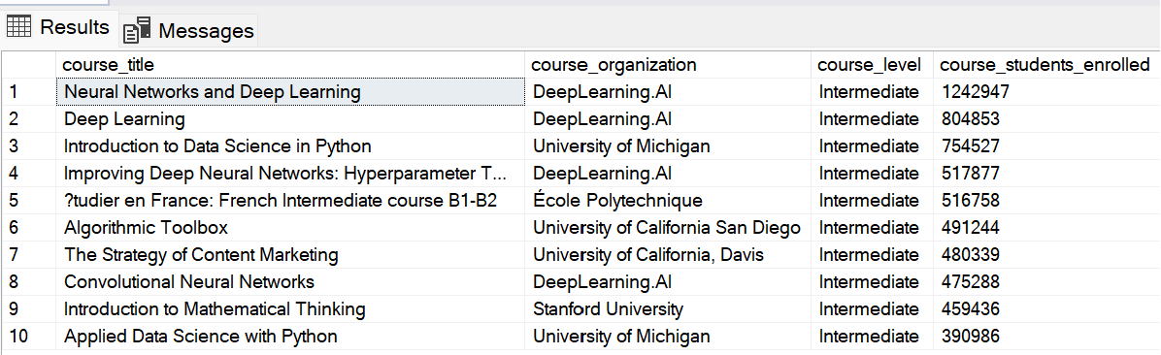

**Part 3: Top 10 Advanced level courses based on student enrollment**

SELECT TOP 10

course_title,

course_organization,

course_level,

course_students_enrolled

FROM coursera_courses

WHERE course_level = 'Advanced'

ORDER BY course_students_enrolled DESC;

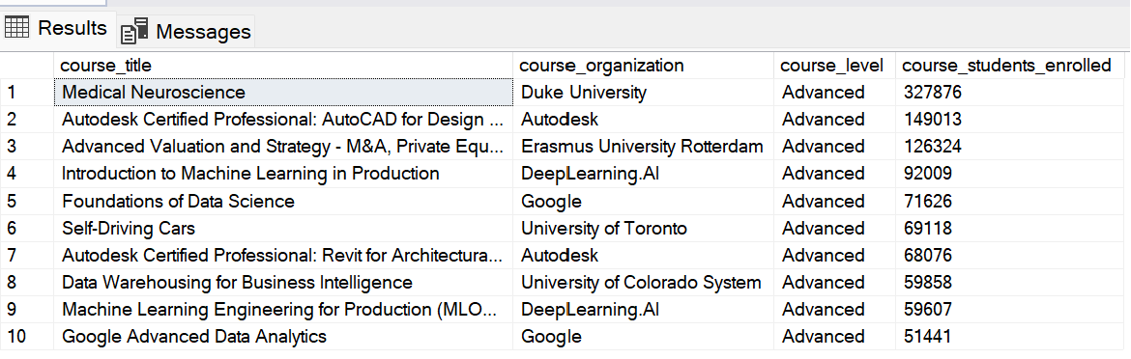

**Part 4: Top 10 Mixed level courses based on student enrollment**

SELECT TOP 10

course_title,

course_organization,

course_level,

course_students_enrolled

FROM coursera_courses

WHERE course_level = 'Mixed'

ORDER BY course_students_enrolled DESC;

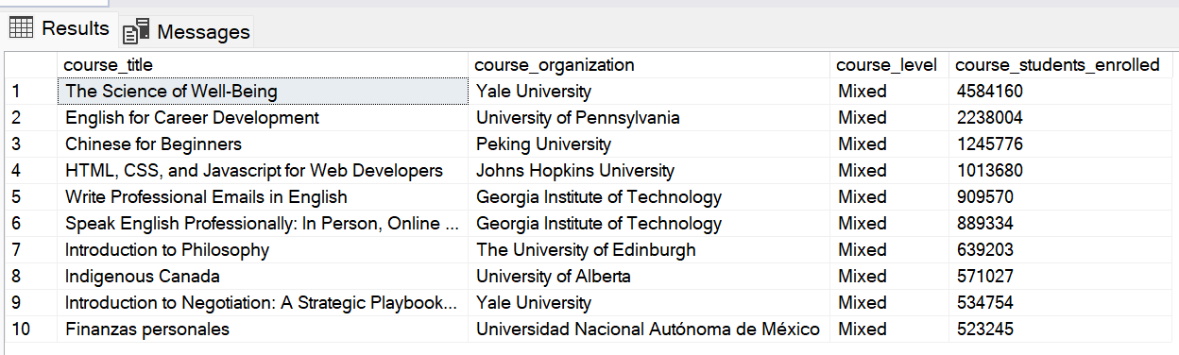

1. **What are the top 10 performing courses in each certificate type (Course, Specialization, Professional Certificate, and Guided Project)?**

**Part 1: Top 10 Courses based on student enrollment**

SELECT TOP 10

course_title,

course_organization,

course_certificate_type,

course_students_enrolled

FROM coursera_courses

WHERE course_certificate_type = 'Course'

ORDER BY course_students_enrolled DESC;

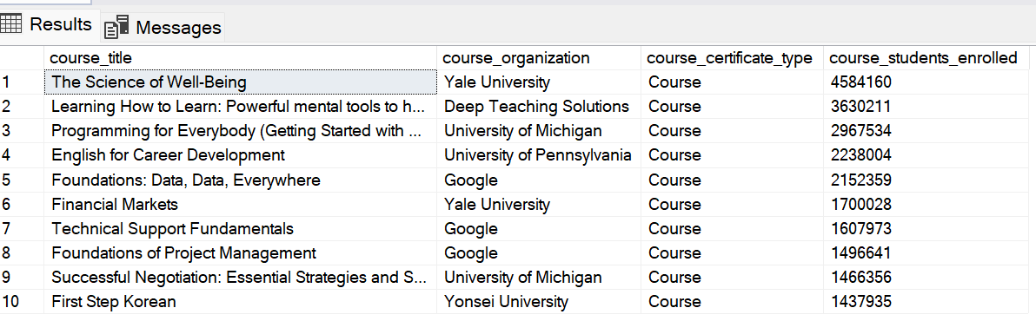

**Part 2: Top 10 Specializations based on student enrollment**

SELECT TOP 10

course_title,

course_organization,

course_certificate_type,

course_students_enrolled

FROM coursera_courses

WHERE course_certificate_type = 'Specialization'

ORDER BY course_students_enrolled DESC;

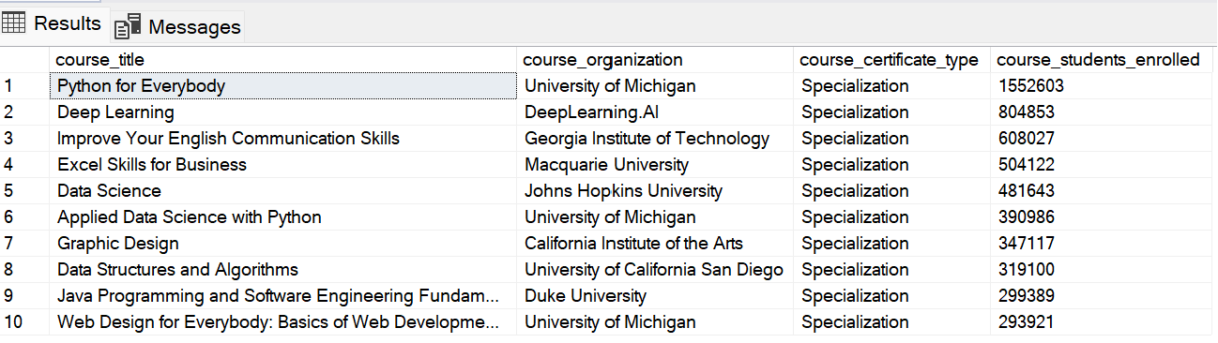

**Part 3: Top 10 Professional Certificates based on student enrollment**

SELECT TOP 10

course_title,

course_organization,

course_certificate_type,

course_students_enrolled

FROM coursera_courses

WHERE course_certificate_type = 'Professional Certificate'

ORDER BY course_students_enrolled DESC;

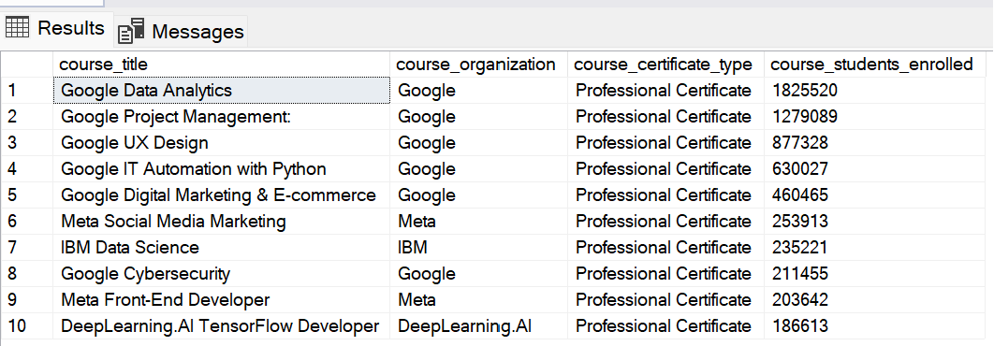

*Observation: Google, Meta, and IBM offer the most in-demand professional certificates.*

**Part 4: Top 10 Guided Projects based on student enrollment**

SELECT TOP 10

course_title,

course_organization,

course_certificate_type,

course_students_enrolled

FROM coursera_courses

WHERE course_certificate_type = 'Guided Project'

ORDER BY course_students_enrolled DESC;

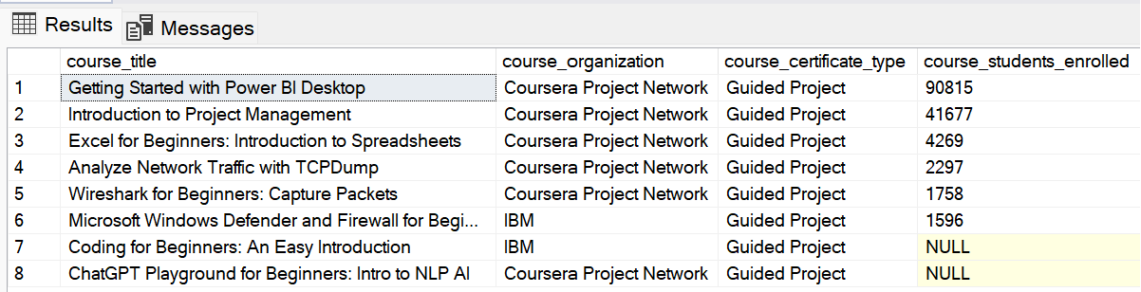

*Observation: Guided projects from Coursera Project Network are the most in-demand.*